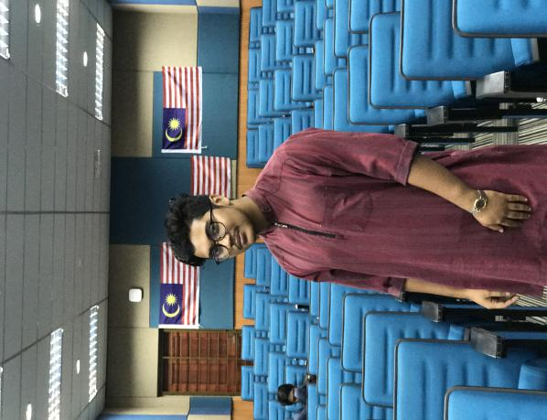Syafir Ahmad bin Aharar Ahamad

+60 (013) 4862862 – syafir96@gmail.com

# SUMMARY

**Syafir Ahmad** 21 years old. Single. I can be described as a competent and skilled mobile application and repairing technician. I have passion in teamwork.

# Experience

Assistant manager

Aharar Bayuemas March ’14 – September’17

* Manage the store financial
* Take care of lay out stock in store.
* Cashier
* Managing Accounts

Computer Technician

AONEPLUS SDN BHD November ’15 – February ‘16

* Repairing
* Retail Assistant

# Education

Ampang community college

Diploma in Mobile Technology 2016 - 2018

Kuala langat community college

Certificate in Computer Application System 2014 - 2015